December 2017 & January 2018 Volume 8 Number 8
In this issue…
From the Rector............1 & 2
Andy’s Poem.......................2
Saints’ Days.………..……..3
An Advent Memory…...…3
Christmas Services……….4
Safety………………………4
Vestry News........................5
Alma’s Poems…………….5
Sandi’s Column…………..6
Saintly News…………...…6
Prayer Ministry…….……..7
Hungry Students…………7
Book Note............................8
Pastoral Care……………...8
Vestry Candidates…….9-10
From the Bench……...…..11
Editor’s Note.....................12

All Saints’ Church 51 Concord Street, Peterborough, NH 03458
Parish Office: (603) 924-3202 Office Hours M-Th 9 AM-2 PM
Web: allsaintsnh.org Office Email: admin@allsaintsnh.org
Jamie Hamilton, Rector Her email: revjamie@allsaintsnh.org

Our Mission (What we do)
Our mission is to help people grow in their faith and trust in God by helping them recognize their God-given talents and to use them to serve God and their neighbor.
Our Vision (Where we are going)
Our vision is to be a community in which God’s love is experienced and shared.

Dear Parishioners,
Over a year ago, while I was working out at the Wellness Center, a gym acquaintance asked me if All Saints’ was buying a parking lot.
“Yes,” I responded. “We’re excited by the possibility.”
“Really? If I may be so blunt, isn’t that being awfully optimistic? Aren’t the mainline churches dying? Won’t the next 25 years prove to you that your purchase was a waste of your resources?”
Wow, I didn’t see that coming. Maybe people feel more free to speak after endorphins are released from exercising. I was taken aback, so I said, (maybe a little flippantly), “You know, the church knows something about dying, and it’s this: death never has the last word.”
I think that’s called a conversation stopper. Looking back, I wish I could have had this conversation instead:
About 2600 years ago, Prophet Jeremiah, while living in a Jerusalem under siege, bought a plot of land. The Babylonians had marched in, camped in the city streets, and were destroying life as everyone knew it. The enemy was pillaging, plundering, and burning the place down. Nothing was sacred. Everything was smashed. And yet, while the survivors were being carted off to the outer darkness of Babylon to be forever swallowed up in the diaspora, Jeremiah stepped aside to buy a plot of land! He took the land deed and sealed it in an earthen vessel, to keep it safe as a sign of hope of his people’s return.
A real estate investment nightmare turned prophetic!
I’m not suggesting that Mainline Christianity is under enemy siege, but my gym mate was. And he has a point. Long gone are the days that people belong to the church of their parents “just because.” Numbers of Christians are dropping and ‘Nones’ are soaring. Yet, instead of interpreting this so-called “decline” as dying, I think we should see it as clarifying. Instead, people, including the young, are becoming a part of church as a deep-seated commitment to the living Christ. I don’t think that’s a bad thing. In fact, it might be just the right time to buy a plot of land!
We have something to live for: we follow Jesus unabashedly. He’s the real deal. And by following the way of Jesus, we embrace the Holy Spirit of human potential that is found here and now, rightly called the Kingdom of God. We are inclusive with doors flung open: we believe in reconciliation, healing, forgiveness, mercy and hope. We trust in making ourselves anew, deeming our inter-dependence as a thing of beauty. We find courage in recovery, meaning in mission, and power in contemplation. We believe that the only thing that matters is faith expressing itself in love (Galatians 5:6). The world is a-thirst for these living waters.
Continued on next page…
…continued from page 1
Today, 100 years after the first cornerstone was set, we are setting a new cornerstone for All Saints’, jump-started by buying a parking plot of land (God’s sense of humor). And yet, here we are. The results of our Tentative Case Statement and Feasibility Study encourage us to trust in our capacity to raise money through a Capital Campaign (the full report is linked on our website). And now during the season of Advent, as we wait for the birth of the Christ that burns already within us, we have the opportunity to pray, reflect, share, question, debate, ponder, discern and deliberate over our proposed projects and to continue to articulate with each other how completing these projects will continue to support us as we follow the way of Jesus.
We need your thoughts and prayers and input as we move forward, building on our trust in God’s call to be God’s people.
By the way, just last week, another gym buddy said to me, “You know, I don’t go to church, but it’s way cool to drive by All Saints’ on Sundays and see how packed your new parking lot is.”
Way cool! Imagine, a parking lot as a tool for evangelism!
Merry Christmas!
With much love,
Jamie+
The Messenger
Sue Ernst, Publisher 207-716-2151
Gail Anthony Publisher Emeritus, 924-3534
Christine Howe Editor, 759-5626
Brad Taylor Assistant Editor 924-6595
Production
Janet Fiedler Steve Fowle
Bev Kemp
Alma Ruth
Charlie Ruth
Bob Weathers

The Vestry
Senior Warden
Phil Suter

Junior Warden
Greg Naudascher
Clerk of the Vestry
Philip Huckins
Treasurer Christina Meinke
Assistant Treasurers Kelley Conley Arthur Eldredge Steve Smillie
Vestry Members
John Catlin Joan Cunningham Pam Everson Beth Healy Barbara Kaufmann Madelyn Morris Lara Niemela Autumn Roberts Sally Steere

Advent
The air is glowing with Christmas lights
Christmas carols and other delights
Although my light is very small
That doesn't stop me at all
As I welcome the coming of the Divine
I'm going to let it shine
Love, Alma
Advent
The air is glowing with Christmas lights
Christmas carols

Happiness is not an Overcoat

Happiness is not an overcoat
To be put on when times are bad
Or times are good--for if we only could
Don a garment to be glad
If we could trust in our possessions
To make the angels sing
Then why go to the bother
To see in a fellow being
The love that springs eternal
And ever is brand new
Come sit here by the fire
For that coat will never do
The work of ageless glory
Found in your eyes so blue
Let’s learn to love each other
And laugh this Christmas, too.
Andy Peterson

December Saints’ Days

12/1 William Raymond
Timothy Ryan
12/2 William Marot
12/3 Janet Fiedler
12/6 Hellyn Egan
Christine Howe
12/7 Lily Bell
12/9 Hadley Bates
Carleigh Brown
12/10 Renée Charney
12/11 Max Scheinblum
12/12 John Calhoun
Martha Manley
12/15 Deborah Rogers
12/16 Catherine Cauthorne
12/17 Matthew Belliveau-Ryan
Michael Carter
Caroline Sarles
12/18 Barbara Wood
12/19 Sheridan Johnston
12/20 Sarah Kendall
Carl Wagner, jr.
12/21 Kate Coon
12/25 Jesus of Nazareth
12/26 Finnian Brown
William Cahill
12/27 Lois Whalen
12/30 Nicholas Ryan

January Saints’ Days

1/01 Andrew Goss
1/03 Lucas Gregory
1/05 Ryan Betz
Peter Oliver
1/06 Jerry Branch
Tommy Goodwin
Beth Krommes
1/07 Lilianne Tullio
1/08 Megan Graff
Charles Richmond
1/09 Christine Kelly
1/12 Mary Weis
Susan Sarles
1/14 Emily Manns
1/17 Martha Raymond
Libby Twitchell
1/18 Susan Gill
1/19 Heather Peterson
1/20 Louise Lawrence
1/23 Claire Marlar
Isabella Zielie
1/24 Laura Campbell
Finbar McCullough
1/25 Elisabeth Foecking
Bailey Guinn
Catherine Pendleton
Judith Pratt
1/26 Lily Beyer
1/28 Elsbeth Pendleton
1/31 David Boothby
Naomi-Clare Praul

An Advent Memory
Many, many years ago I was a tween in Winthrop, Massachusetts. My family--mother, father, younger sister and I--attended St. John’s Episcopal Church regularly. One Advent season our minister, Mr. Harper, challenged the Church Sunday school students to memorize an Advent Prayer. If we did so, we would receive a red candle.
The red candle is long gone, but that Advent Prayer has remained a part of my Christmas ritual. I have a framed copy given to me by a long-time friend that has hung somewhere in my home each season. The words maybe old-fashioned, but the thoughts are eternal.
O, Christ, grant us thankful hearts today for thee, our choicest gift, our dearest guest.
Let not our souls be busy inns that have no room for thee or thine,
but quiet homes of prayer and praise where thou mayst find fit company.
Where holy thoughts pass up and down and fervent longings watch and wait thy coming.
When thou comest again, oh Holy one,
Mayest thou find thy family waiting for no new master, but one loved and known.
Even so, come Lord Jesus.
AMEN
Bev Kemp

The Feast of the Nativity

Christmas Eve
4:30 pm: The Pageant of the Nativity and Holy Eucharist
A dramatization of the Nativity Story by children of the parish with the Pageant Choir

7:30 pm: Festal Holy Eucharist
with organ and carols

10:30 pm: Music for the Feast
~ A Wreath of Carols ~
music by Brahms, Monteverdi, Prætorius, Rutter, Winslow and Willcocks
for organ, choir, and congregation with Apple Hill Strings

11:00 pm: ‘Midnight Mass’
with the All Saints’ Choir and Apple Hill Strings

Christmas Day
10:00 am: Festal Holy Eucharist
with organ and carols

The First Sunday after Christmas Day
10:00 am: Holy Eucharist
with organ and carols

Celebrating the Season Safely
Did you know? Members of the Vestry and Buildings and Grounds committee have created a running list of needs based on health, safety and access that, when completed, would continue to support all that you may wish for our parish community. Several of the projects on the list have been considered and discussed for many years, sometimes stymied by a lack of people power or funds or prioritizing or all of the above.
It became clear during our cottage meetings last spring that ease of access and safety is a high priority, and that by paying attention to safety issues, we are practicing hospitality. People need to feel comfortable from the moment they pull off Concord Street to park, whether it is to come to a meeting, choir practice, a wedding, a meal, a concert, or church services.
With safety on our minds, it’s been easier to prioritize. We would like to hear your suggestions in how to make this campus more welcoming. We need better signage, maybe some kind of crossing guard, and stronger lighting. Do you have any other ideas? Welcome, safety, and easy access are key to inviting all of us, friends, neighbors, and parishioners to gather together.
Please know: The Buildings and Grounds committee welcomes your input. Please reach out to any one of us on the committee: John Catlin, Sally Steere, Carol Walsh, Paul Freeman, Jack Lewis, and Matt White. If you would like to share your views with the full committee, please email me at gretchen@allsaintsnh.org and I will make sure that the committee hears your suggestions. Thank You!
Gretchen Rae, Projects Manager
Vestry News

It’s a busy time of year for vestry as we prepare for Advent, Lessons and Carols on December 17 and Christmas! In the midst of so many wonderful celebrations, we are also wrapping up the fiscal year 2017 and preparing All Saints’ budget for 2018. We met twice in November.
Our treasurer, Christina Meinke, reported at our November 8 meeting, that as we approach the end of 2017, our pledge income and expenses are on budget for the year. Yes, we do need to fulfill our 2017 end-of-year pledges by December 31. We thank you in advance for fulling your 2017 pledge!
Christie and Susie Vogel, our bookkeeper, prepared a preliminary 2018 Budget worksheet which the vestry discussed at an extra meeting on November 29 and at our regularly scheduled meeting on December 13 in preparation to present at our Annual Meeting on Sunday, January 28 after the one 9:30 service that day.
We celebrated our 2018 stewardship campaign at our In-Gathering Sunday and Celebration Brunch Sunday October 22. Thank you to all of you who have already generously made your pledges for 2018. If you have not yet had a chance, we welcome you to make your pledge, and to please contact Jamie or Gail Caron in the office with any questions. Our pledges of financial support for our church are important as we say, “Yes” to God’s work.
As you may know, the Tentative Case Statement and a Feasibility Study/Questionnaire was either emailed or mailed to parishioners in early November, with responses due back by November 13 to the Episcopal Church Foundation (ECF). We had a 57% return rate, which is excellent. ECF compiled our responses and Leslie Pendleton, our consultant with ECF, joined us for services on Sunday, December 3. After both services, Leslie shared with us a comprehensive summary of the report, reflecting the aggregate of everyone’s input which was very positive toward the possibility of a Capital Campaign and that our goal of $570,000 was within reach. If you would like to read the full report, you can find it on our website (under the tab “Campaign Information”) or check out a bound copy of the report in the church office. Our responses to the Feasibility Study is helping the Vestry to determine how we move forward to support and achieve our shared priorities.
We closed on the sale of 44 Concord Street on December 7. A big thank you, especially to the members of the Building and Grounds committee, who have worked diligently in making this sale possible.
During Advent and into the New Year, members of the Vestry welcome parishioners’ continued thoughts, questions, reflections and insights about our continued discussion of All Saints’ next 100 years.
We thank you for all the ways you love All Saints’ and your vestry enjoys working with you in all the ways we can make a difference in each other’s lives, in our community, and in the world.
Beth Healy, Vestry Member
Advent
The air is glowing with Christmas lights
Christmas carols and other delights
Although my light is very small
That doesn’t stop me at all
As I welcome the coming of the Divine
I’m going to let it shine.
Love, Alma
The New Year
Get ready now
Put your hands to the plow
Remember your Christian vow
Welcome the changes planned
And give a helping hand
We start a new path together
No matter what the weather
God is with us still
Let's serve under His will
Love, Alma

Ransomed Hearts
I often sing when I’m home alone. Sometimes the cats join in, but mostly they ignore my warbling. Most of the time the songs in my head are ones I heard in church that week or in the grocery store. Today found myself walking around the house singing one I’ve heard recently in both places, thanks to the ways that secular and sacred collide in this Christmas season. “O come, O come Emmanuel, and ransom captive Israel”. A word caught my attention and the wheels started turning: ransom…ransom.
According to Webster: ran·som (ˈransəm), to release (a prisoner) after receiving payment. synonyms: release, free, deliver, liberate, rescue; see redeem
When we hear the word ransom we might think of kidnapping victims: children stolen from their wealthy parents by evil people, demanding money in exchange for their lives. But we, as Christians have a very different sense of ransoming. Our captivity as human beings manifests in the so many different ways we choose to separate ourselves from each other and from God. God's saving compassion for you and me is the good news of God’s amazing grace and love in the Incarnation.
This incarnation, Emmanuel, God with us, is Love beyond all measure. It is God’s desire for relationship, manifested so strongly and so deeply that God became human, born of a woman, to breathe the very same air we breathe, and walk the very same Earth we walk, to know our pain and our joy. When I think of this I am overcome with such wonder and gratitude for this gift of freedom offered to me in Christ’s life and in his sacrifice at the very human hands he came to offer everlasting life.
So, as we move from Advent to Christmas and forward, what are we to do with our ransomed, released, delivered, liberated, rescued and redeemed selves? How do we live into this precious gift offered so freely from the One who loves us so very much? May this be our challenge and our joy in the days to come. Rejoice, Emmanuel has come to thee…
How silently,
how silently
the wondrous gift is given.

I would be silent now,
Lord,
and expectant . . .
that I may receive
the gift I need
so I may become
the gift others need.

Ted Loder, I am Silent. . . and Expectant
Sandi Albom, Curate

Saintly News
Congratulations to…

- Jay Hale for being honored at the Harris Center and for receiving the Laurie Bryan Partnership Award.

If you would like to share a “special” news item or a happy occasion with the Parish, please email Gloria Schultz at glojoemointheglen@gmail.com or call 924-9489.

Thank You, All Saints', from the Hungry Students Program

Prayer Ministry at All Saints
“For where two or three have gathered together in My name, I am there in their midst." Matthew 18:20
There are some changes in the prayer ministry coming in January 2018. One’s prayer life is so personal, people often feel insecure about sharing it. We hope this new format will encourage people to grow in their personal prayer life and grow our corporate time of prayer as a community of believers at All Saints’. Our Wednesday morning group will be moving to a weekly meeting on Tuesdays at 5 PM in the Old Parish Hall. We have a new format, spending 20 minutes with scripture and a devotional reading from We Make the Road by Walking by Brian McLaren. The remaining time will be spent reviewing the prayer requests from the parish and praying other requests that might be brought forward during our meeting.
We understand it is difficult to make a weekly commitment, but hope to draw people who want to expand their prayer life and serve our parish in this vital way. We want the parish to know that everyone is invited to join us any Tuesday afternoon. We hope people who attend the community meal could join us before they go to Reynolds Hall. All prayer requests that come to us are held in confidence. Those who have been part of this group have found this ministry to be a significant time in their faith walk.
Our Sunday morning healing prayer team is looking to expand its ranks, as we want to offer this confidential time of prayer during the Eucharist every Sunday at 10 AM. We need to always have two people present to offer prayers on someone’s behalf. If someone is drawn to pray for others but is not sure how to go about this, we invite you to stand with us and be present. We will be offering some time of orienting to this role in the New Year.
Please contact me with any questions at nina.pollock@gmail.com or 525-3612.
Nina Pollock, for the Prayer Ministry

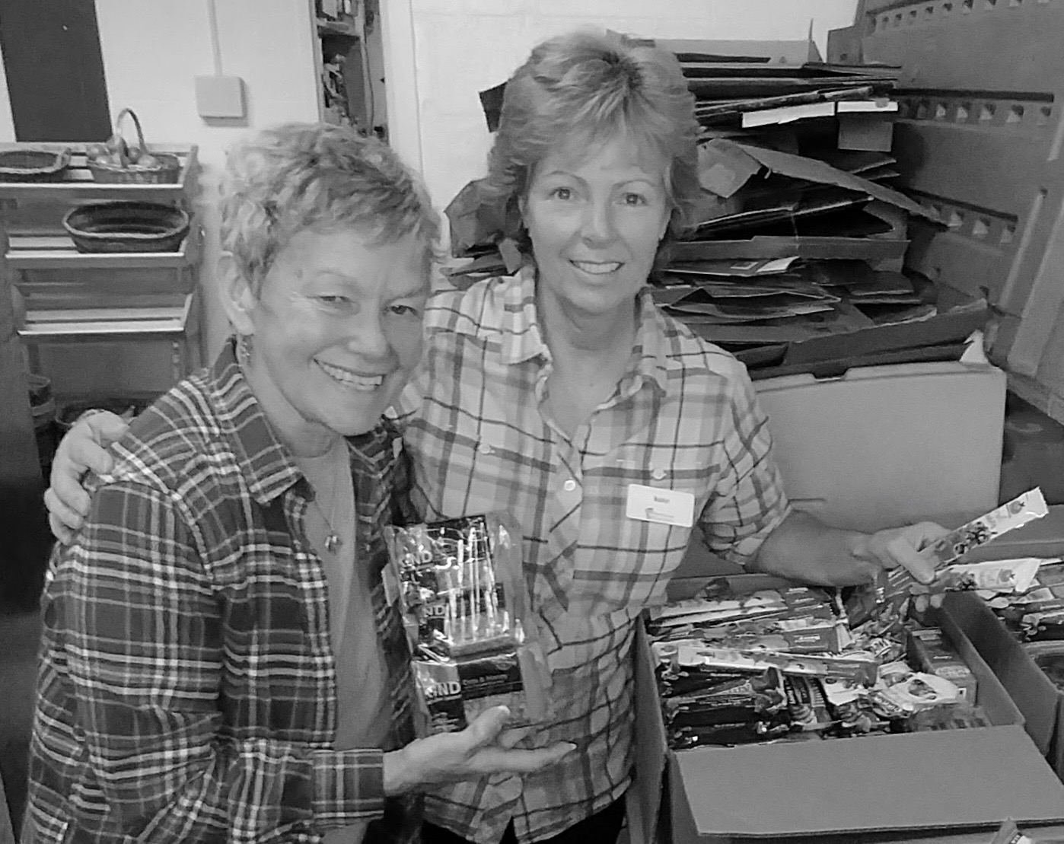
It is a season of thankfulness; it is a season of giving and receiving! With much gratitude from all ten school systems you are supporting with your generous snack donations each week, I bring you glad tidings. You have contributed to the joy of so many children and their grateful teachers, school nurses and social workers. You have said you care about their dignity, their ability to concentrate in class, their need to feel confident and given them more than physical nourishment. You have said you can count on us by your willingness to keep the basket overflowing in supplies.
We have packed 20 very full boxes of healthy snacks for children around the Conval school district since the beginning of the school year, some schools requiring more assistance than others because of economic disparities. You are giving voice to an identified need invisible to many and creating a beautiful connection, magnifying what All Saints' stands for. I had a school nurse apologize for asking for more snacks. You all gave me the ability to tell her if the need is there and we have the supply then that is a match made in heaven and we are honored to deliver. Most of the need is during school hours but we are also meeting some of the need during after-school programs. As parents, we know how hungry kids are when they come home from school!
All Saints is on their lips of praise and gratitude and you have made a significant impact in many lives. May we continue to answer the need and the call. You are the gift.
Merry Christmas, All Saints’!
Madelyn Morris, liaison for the Hungry Students Program

Book Note
G. K Chesterton (1874-1936) was a literary powerhouse. If nothing else, you are likely to have encountered him in the “Father Brown” detective stories, upon which the PBS series is very loosely based, and also in one hymn in our hymnal: ”O God of earth and altar”, hymn 591. Those two things give a fair idea of the range of interest and style of this impassioned, paradox-prizing, skeptical, devout Christian journalist.
He was, above all, a journalist. He wrote novels, poetry, literary and dramatic criticism, essays, biographies; but he was always, by temperament and habit, a journalist, incapable of accepting anything simply on authority (including the Roman Catholic Church, which he formally joined in 1922). He was determined to make sense of a world that had clearly gone mad.
I have just finished reading Chesterton’s The Ball and the Cross, first published in 1907, a short novel of the attempt of two men, one the publisher of atheist tracts, the other a Scottish Highland Roman Catholic, to have a duel for (and against) the honor of the Blessed Virgin Mary. The forces of order in the modern world take a dim view of this, and thwart them repeatedly, but the two can’t be stopped from having adventures, or from arguing theology. It is both romance and shaggy-dog story, light and comic in tone, but with a resonant burden of concern for ordinary people in peril.
A word of caution: this is a product of its time. Edwardian sensitivities were not ours, their unexamined biases clear to us (as ours will be to those who come after us). I noticed several such instances in this particular book: if you would rather avoid them, then just pick a different book: The Man Who Was Thursday, for another novel; Orthodoxy or The Everlasting Man for very readable theology; one of his essays (“Travel”, he claims, “narrows the mind”); and, of course, the real Father Brown stories, beginning with The Innocence of Father Brown, with their elevation of reason and human perceptiveness in the person of an ordinary-appearing Roman Catholic priest from London.
All stimulating; most entertaining, even fizzy; but struck though with the passion for justice and community that shines so powerfully in the hymn:
From all that terror teaches, from lies of tongue and pen,
From all the easy speeches that comfort cruel men,
From sale and profanation of peril and the sword,
From sleep and from damnation, deliver us, good Lord.

Cassius Webb

Pastoral Care Ministry
Friday, January 19 at 5:30 PM.
Please join us for hors d'oeuvres
at the rectory
We look forward to the opportunity to be with you
and to discuss the work of this ministry
New members are welcome!
Please RSVP to Heidi Graff
heidigraffnh@gmail.com
547-0783

Vestry Candidates
Heidi Graff - I have been a member of All Saints’ Church for 12 years, usually attending the 10 AM service along with my husband, Andrew, and our three daughters, Ellie, Anna and Meg. Over the years, I have been involved in a variety of ways at All Saints’. A former member of the Outreach Ministry, I volunteer at the Serendipity shop, enjoy hosting coffee hour from time to time and am currently the leader of the Pastoral Care Ministry. In addition, I help with fundraising efforts for Centro Victoria and have traveled to Juarez for the past three years on the annual June service trip. I live in Rindge and am a certified Spanish teacher, although, not currently teaching. In my free time, I love walking our rescue dog, Juniper, who just turned one, and I love to cook. I look forward to serving on the Vestry.

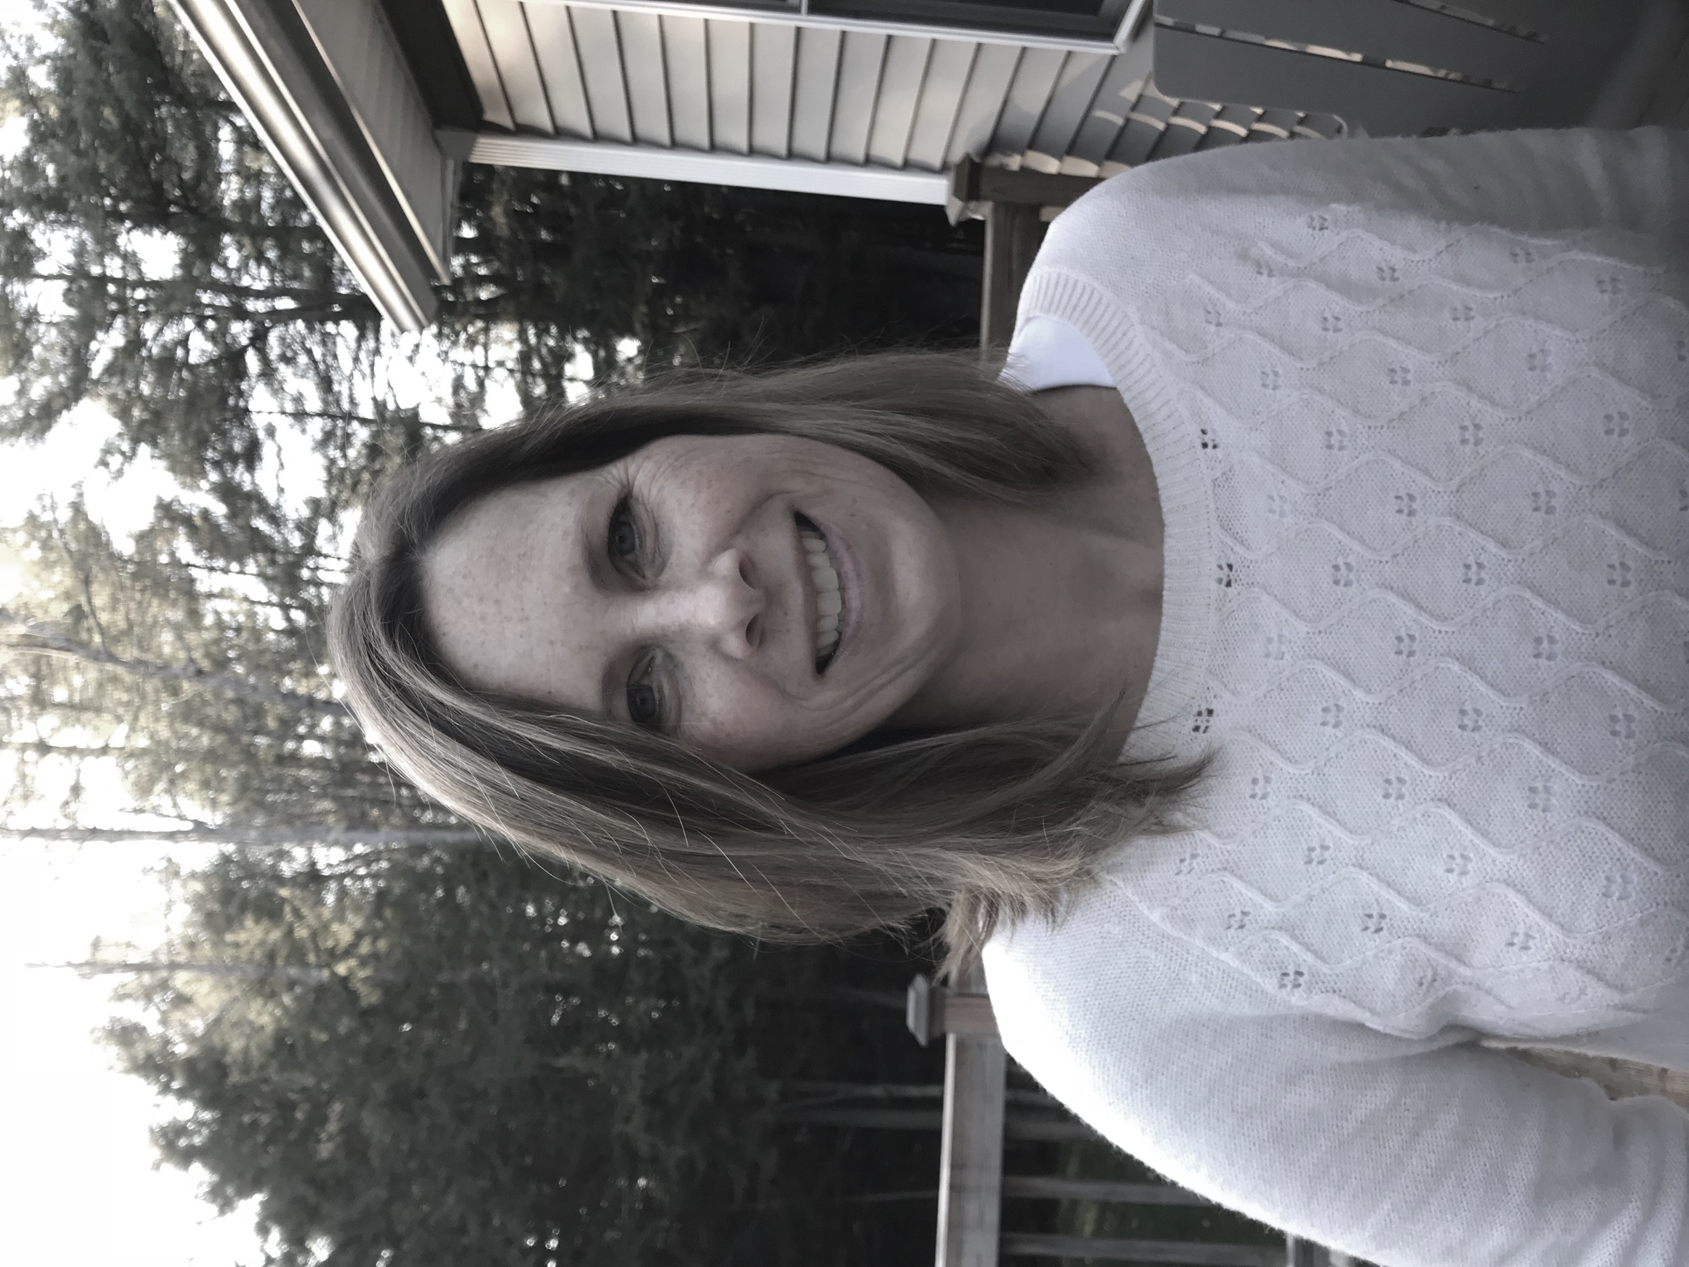

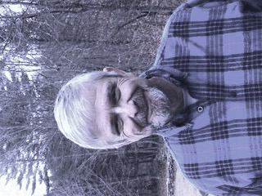
Tim Riley--I’m honored to be considered for service on the Vestry. My wife Amy and I have been attending All Saints’ since we moved to Peterborough from the Boston area in 2016, and although we attended various Episcopal and Unitarian congregations in the Boston area, we have never felt more at home in a faith community than we do at All Saints’. Amy and I have two adult children--one who is a student in Boston and a second who is living and working in Kenya. I worked for over thirty-five years in the human resources and organizational development fields. I’m inspired by the life and teachings of Jesus as a role model for interpersonal relationships and social justice. I have enjoyed serving on the Outreach Committee, visiting Centro Victoria, and facilitating small group discussions in the vision work that All Saints has undertaken this past year.

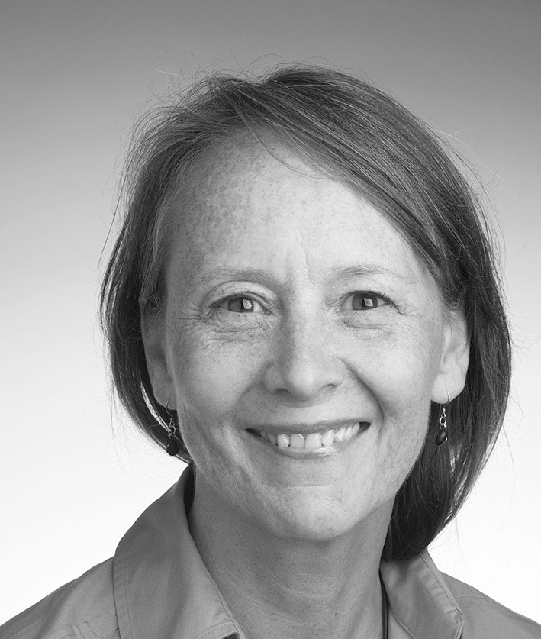

Margaret Baker— I grew up in Rhode Island and attended St. Stephen’s Episcopal Church for 18 years. My mother and father both served on the vestry; my father as treasurer, my mother as clerk. I have fond memories of helping my father (and other vestry members!) count and catalog the plate offering every Sunday. To this day, I have a compulsion to make sure my bills are in numeral order and facing the same way!
After college, I took a 20-year hiatus from church, then found myself coming back about 10 years ago. It was Christmas and I was newly divorced. Tricia Rose Burt invited me to go to a service with her. I felt like I was home again. I love every service at All Saints’ and especially Rite Now in Reynold’s Hall.
Professionally I’m a graphic designer and have had my own business in Peterborough since 1986. In 2014, I started working at the Harris Center for Conservation Education as their Communications Specialist, while scaling back (but still keeping) my freelance work. It makes for a nice and lively balance.
I’m honored to be considered for the position of clerk on the All Saints’ vestry.
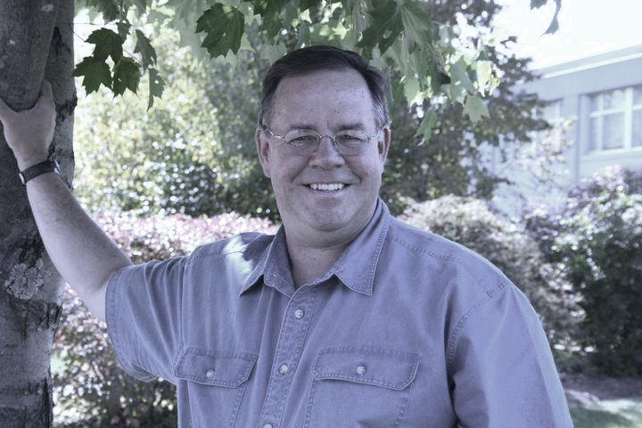
Jack Calhoun – Raised in the Congregational Church, I “discovered” All Saints’ in 1984 when the Choir Director asked members of the Monadnock Chorus to sing parts of a Beethoven Mass during a service. The beauty of the church and service were compelling, and I began attending services and was confirmed in 1986. I married at All Saints’ in 1987, and it is where my children, Peter (28) and Nelly (26), were baptized. During my divorce in the late ‘90s, I struggled with “organized religion” for about five years. Nevertheless, it was a period of spiritual growth for me, and in many ways, I felt closer to God than at any other time in my life. I “re-connected” with the church beginning in 2004, attending regularly with Beth, my wife. Rev. Adrian married us in a fog shrouded meadow above our village of Harrisville in September 2006. My spiritual journey is nurtured by All Saints’, and I’m inspired equally by other parishioners and Rev. Jamie’s leadership. Currently I lead the Usher Ministry and am in Year 1 of Education for Ministry. Outside of All Saints’, I served as trustee and board chair for Monadnock Conservancy, Harris Center, and Apple Hill Center for Chamber Music. I’m also a trustee of the Community College System of New Hampshire. I look forward to serving All Saints’ in these challenging times to help our community be all that it can be for parishioners and the world beyond our campus. I received a BA and MBA from the University of New Hampshire.

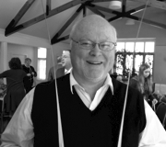
Phil Suter-- I have been a parishioner for about six years – the last four on the Vestry, and the last three as Senior Warden. At the suggestion of the Rector, and for the sake of continuity of projects currently underway, I’ve gladly agreed to stand for election to another term.
In my professional life, I serve as President/CEO of the Greater Keene Chamber of Commerce. Prior, my experience includes teaching at both UNH and Antioch; management and marketing consulting; more than a dozen years in the Foreign Service; and advertising/marketing.
I’m a life-long Episcopalian who took a decade or three off. Among the many things that drew me back into the Episcopal fold a decade or so ago was something I read while looking at St. John’s in Portsmouth as a spiritual home: “No matter where you are on your journey of faith, you are welcome at St. John’s, and most importantly at God’s table.”
I was born in Brattleboro, and grew up mostly in Massachusetts. I graduated from Milton Academy, The Colorado College, and UNH (MBA).
I’ve served on the board of the Peterborough Folk Music Society, and enjoy as many rounds of golf as New England seasons permit. I live in Peterborough.

View from the Bench
Music for the Feast
…the stars shall bend their voices, and every stone shall cry…
Each year at All Saints’, before Christmas Midnight Mass, we enjoy ‘Music for the Feast,’ a half-hour program of Christmas music. When funds have been available to hire instrumentalists, ‘Music for the Feast’ has included such works as Benjamin Britten’s Ceremony of Carols, Johann Kuhnau’s Es ist ein kind geboren, Antonio Vivaldi’s Gloria, Ralph Vaughan Williams’ Fantasia on Christmas Carols, Stephen Paulus’ Christmas Tidings, Gwyneth Walker’s Rejoice, Antonio Corelli’s Christmas Cantata, and excerpts from J.S. Bach’s Christmas Oratorio. In leaner (or icier) years, ‘Music for the Feast’ has variously been an organ recital, a congregational carol sing, or a themed choral program like last year’s Neo-Gothic Christmas.
This year, I invite and encourage you to be present at 10:30 PM on Christmas Eve for Music for the Feast: A Wreath of Carols. We will have with us members of the Apple Hill String Quartet and other musical friends who will accompany a program of Christmas hymns and carols from the 16th century to the present, employing a variety of musical forces -- string quartet and quintet, organ, congregation, choir and soloists. The program will begin with a setting of Claudio Monteverdi’s Christe Redemptor omnium for string quintet and organ. Following will be a 20th century string quartet setting of Michael Praetorius’ 16th c. Es ist ein ros’ (Lo, how a rose), in the midst of which the choir and congregation will join in singing the much beloved carol. A third treatment of the same carol will be Johannes Brahms’ 19th c. chorale prelude for organ. Strings, choir, congregation, and organ will then join in an arrangement of the familiar Christmas carol, “While shepherds watch their flocks by night.” The choir will sing Christina Rosetti’s “Love came down at Christmas” in a musical setting by John Rutter, accompanied by string quintet. Full musical resources, including the congregation, will then join in singing David Willcocks’ setting of “It came upon the midnight clear.”
The final musical work included in A Wreath of Carols has an interesting story behind it. The lyric, A Christmas Hymn, is by Richard Wilbur (1921-2017), a Pulitzer Prize-winning poet, who was a faculty member at Wesleyan University and a former U.S. Poet Laureate. A Christmas Hymn has received numerous musical settings over the years: a hymn in our Hymnal 1982 by David Hurd, a wonderful anthem the All Saints’ Choir sang a few years ago by British composer Bob Chilcott, and a solo setting by no less an icon than Dave Brubeck.
The real impetus for Wilbur’s poem, however, came in the 1950s when composer Richard Winslow (1918-2017), also a Wesleyan faculty member, asked Wilbur to write for him a Christmas text that he could set for an upcoming university Christmas concert. It is that setting that two soloists will sing Christmas Eve, with organ and double bass. (Aside: Winslow, after his retirement, made his home in Antrim, NH).
A Christmas Hymn is built on an epigram from St. Luke’s Gospel at the Liturgy of the Palms in Year C, when Jesus silences the Pharisees who are anxious about the noisy crowds by telling them that, even if these crowds were silent, “the stones would shout out.” A strange source for a Christmas hymn? Perhaps. The text begins “A stable lamp is lighted/Whose glow lights up the sky;/The stars shall bend their voices/and every stone shall cry…/ The recurring refrain, “…and every stone shall cry,” is at the center of each verse of Wilbur’s poem, which winds from birth to death and again to life. A Christmas Hymn concludes: “But now, as at the ending/The low is lifted high;/The stars shall bend their voices/and every stone shall cry. /And every stone shall cry/In praises of the Child/By whose descent among us/The worlds are reconciled.”
A Christmas Hymn parallels the text of Divinum mysterium, the gradual hymn we will sing at Midnight Mass: “Of the Father’s love begotten, ‘ere the world began to be; He is Alpha and Omega, he the source, the ending, He.” As we hear St. John’s Gospel – “In the beginning was the Word, and the Word was with God”–read just before we kneel by candlelight to sing “Silent Night,” what we might have experienced as be a mere sentimental candlelight moment becomes instead our discernment that, from the beginning, this end–birth, death, resurrection and reconciliation–has always been.
Jeffrey L. Fuller, Organist and Choir Director

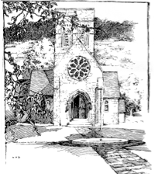
All Saints’ Church
51 Concord Street
Peterborough NH 03458
Non-Profit Postage Paid
Permit #46
Peterborough NH 03458

Editor’s Note
Now that we’ve had our first snow in New Hampshire, I can believe that the holiday season has begun. As Jamie said at the Rite Now service on December 9, “Christmas seems to be coming early this year.” It’s because Christmas Eve, on a Sunday, is also Advent IV. This is also the reason we combined the December and January Messenger this year: there were fewer days than usual between Thanksgiving and Christmas.
This is our last issue with Gail Anthony as publisher of The Messenger. She’s organized our amazing volunteer staff each month to get the newsletter to you, has made many trips to the post office, and has comforted me when I’ve fretted about deadlines or had problems with layout or worried about whom I could ask to write a new column.
I’d known Gail since I first moved to Peterborough in 1986 and joined the choir, and had always appreciated her intelligence, wit and beautiful singing voice.
I’d admired her work on vestry and as Senior Warden, especially during the long interim period when we were waiting for the Robbins-Cole family to move here from England.

But it was when we started working on The Messenger together that I learned first-hand about her dedication to All Saints’ and her understanding of how to bring out the best in everyone.
When we first began publishing The Messenger in its present form, we included a calendar of events and a rota of service participants. Each month, Gail and I would get together for a cup of coffee and conversation and review what was going on in the life of the parish (and in our own lives.) She knew what was going on in every aspect of parish life, and spoke with respect and concern for our church and its members. Gail’s steadiness, practicality and devotion are powers of example for me.
So, thank you, Gail Anthony.
And now we welcome Sue Ernst as publisher. Sue has been a lively presence and her contributions to All Saints’ many since she moved here from Maine a few years ago. We are grateful she has taken on the important task of being Messenger publisher.
The deadline for the February Messenger is January 17. The theme will be “Spreading the Word.” Please send your contributions to me at chow6569@gmail.com.
With much gratitude and great joy,
Christine

